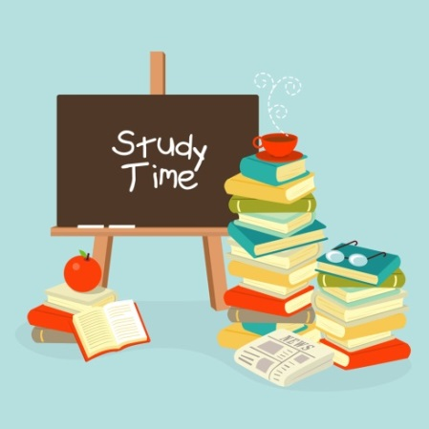
Seaview Primary School
AREAS OF STUDY

Year 2
Dear Parents/Guardians,
This overview will give you an insight into the learning which will be taking place in our classrooms during the month of September and October:

Communication  - During talking and listening activities we will practise speaking in a clear voice for our audience to hear.  - We will recap initial sounds and continue the Phonics Bug Club programme to enable children to use their knowledge of phonemes during reading.  - We will continue to develop our reading strategies when reading unfamiliar words. E-books will be used in class.  - We will be promoting Big Writing in the classroom and use of big wow words. Check the twitter page for weekly wow words.  - In our written work we will work hard to remember to form all our letters correctly with consistency in size and spacing when writing short sentences. Children will continue to use Nelson handwriting programme.  - We will encourage the use of full stops and identify capital letters.  - Children will have the opportunity to listen to a variety of fiction and non-fiction books based around our topic Superheroes. | Using Mathematics  - In our mental maths this half-term, we will primarily be working with numbers within 10/20, counting up and down from different starting points.  - The children should recognise numerals and number words up to 10/20.  - We will be comparing numbers using the following vocabulary; before, after and in between.  - We will develop our adding and subtracting skills with plenty of practical activities.  - We will look closely at 2D shapes, revising their names and properties.  - Children will also explore length – they will engage in concept of measurement, such as longer/shorter.  - Explore body space through different types of movement. This will be linked to P.E time and play time.  - Children will use a range of websites including; TopMarks and ICTgames.com.  - We will use Numicon within our outdoor play.  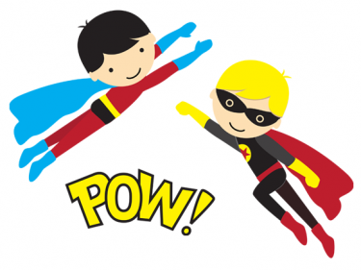
The World Around Us
- This term our topic is ‘Superheroes’ and we will be learning about themselves.
- Some key areas of learning will be:
- All about me – Who am I? Who lives in my house with me? Who can I talk to if I have a worry?
- What do I look like? – naming body parts inside and out. What do you know about your body?
- Healthy Me – what foods do I like to eat? What foods do I need to be fit and healthy?
- Growing food – where do our fruit and vegetables come from?
- Looking at foods around the world – 22nd September 2017
- Senses – what senses do I have? How do different materials feel? Exploring sounds.
- Superheroes – people in my family who have superpowers. Could I be a superhero? Special me – everyone is special and different.
The Arts
- In Music and Drama we will be listening to and performing a variety of songs to become ‘Seaview Music Maestros’.
- Children will develop creativity through imaginative play in home corner role-play and small-world imaginative play.
- In Art we will have the opportunity to create portraits using a range of media and we will look at the work of Kandinsky. Children will explore a wide range of materials and investigate colours, lines and shapes. Superhero art work using a range of natural materials inside and out of the classroom.
PE  In PE children will revise the rules of the hall and safety. They will listen to and follow simple instructions. They will explore and experiment with different ways of movement in the P.E hall. We will begin the basic Fundamental Movement Skills of throwing, catching, jumping, running, balance and coordination. | Using ICT  In ICT this term the children will have the opportunity to explore word processing. We will also enjoy familiarising ourselves with the iPads in our classroom, using a number of educational apps to support our learning across the curriculum. Children will be able to use the’ Seesaw’ app on the iPad to take photographs of their learning journey in school. They will be able to use voice over and record videos during play. Children can use the iPad for learning, such as, Pocket Phonics.
RE  We will begin by looking at the revelation of God through Creation. Children will explore and develop an understanding of the Christian church and, through our school rules, they will begin to have a better understanding of their responsibilities in school. | PDMU  During ‘Circle Time’ we will talk about ourselves, discussing our similarities and differences, things we are good at and recognising what makes each of us special. Children will begin to have an appreciation for their own and others’ feelings and emotions.
Play
Children will experience a wide range of both indoor and outdoor play activities and learning experiences. This will include imaginative and creative play as well as construction and sand/water play. Children will begin to develop an appreciation for the outside world, and our role play corner will be guided by the children’s interests.
For your information
Year 2 Homework Schedule
Monday – Reading books will go home today. The homework for tonight is reading, number and spellings/sounds. There will be 1 written homework per week and this is to be handed in on Thursday signed by parent.
Tuesday – Tonight the homework is reading, number and spellings/sounds.
Wednesday- Tonight the homework is reading, number and spellings/sounds.
Thursday – Please make sure that the reading book, reading record book and written homework is handed in today.
Tonight the homework is revision of all spellings/sounds and number in preparation for a Friday Roundup in school.
All spelling books and homework diaries to be handed in on Friday in the zip wallet. Please make sure they are signed.
Friday – Friday Roundup book will be sent home to parents. Please ensure the children complete any corrections and parents sign. This must be returned to school on Monday.

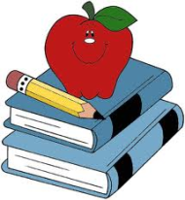

Reminders
- As with all our topic work we appreciate any resources that you may have at home which can add to our class work, in particular our role play area. Please name any items you send in so they can be returned safely afterwards.
- Please ensure your child has their PE kit in school and that all uniform items are clearly named (including PE kit and shoes!).
- Please remember we live in Northern Ireland so it could be sunny at 9am but raining cats and dogs by play time. Therefore, please remember a hooded coat is needed every day.
- Any money being sent to school in your child’s school bag should be placed in a named envelope to avoid any confusion.
- Wellington boots must be brought in and labelled in a plastic bag. These will stay in school for outdoor play.
- Also, could we ask that all children have a spare pair of pants/socks in their schoolbags in case of emergencies!
- 2-3 club money must be sent in to the teacher in a named envelope on a Friday morning for the following week.
- Please remember pick up on a Friday is 1.50pm to avoid congestion.
Thank you for your support, please do not hesitate to speak to either of us with any queries you may have,
Miss Lee and Mrs Bowers.

